**Assignment No : 4**

Q.1) Write a select command that produces the order number, amount, and date for all rows in the Orders table.

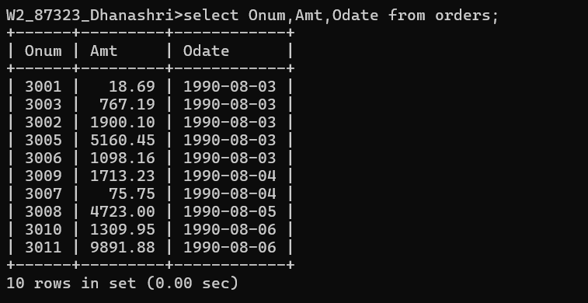

Q.2) Write a query that produces all rows from the Customers table for which the salesperson’s number is 1001.

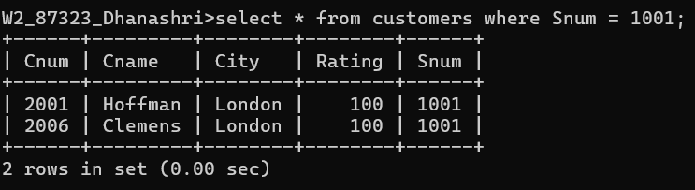

3) Write a query that displays the Salespeople table with the columns in the following order:

city, sname, snum, comm.

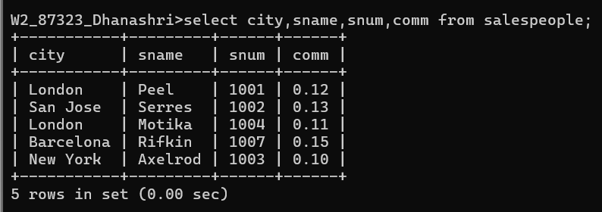

4) Write a select command that produces the rating followed by the name of each customer in San Jose.

